As you travel July 8-12- “Bottle Caps to Benches” Adventure
Day one- Begin the trip with general information about the things you expect to see and do. Then introduce the videos by Tyler Willis about the creation of a documentary.
Hello STEAMers!

My name is Tyler Willis, and I am a former graduate of Thomas University. Currently, I am the Digital Media teacher at Liberty Tech Charter School in Brooks, GA. During my first year at the school, I implemented the use of digital cameras (DSLRs) along with tablets to allow my students the opportunity to tell stories and showcase their understanding of content through mixed media, rather than just simply with pen and paper. It was amazing to see their creations come to life over the course of the year, and it was awesome to watch their content get better and better!

Mrs. Penton reached out to me a few months ago and asked if I’d be interested in helping you all with your documentaries, and I instantly said yes! The items you will use to create your movies are some of the same pieces of equipment that my students at LTCS use every day, so I hope you find the tutorial video helpful to get a head start on setting up and using the various pieces of equipment. Also, I’ve provided two additional videos that will help you think through the process of creating a documentary of your experience.

Additionally, Mrs. Penton found some articles that we’d like for you to check out prior to your trip so that it gets your thoughts focused on what you’ll be experiencing soon!

Video Tutorials
Getting to Know Your Equipment - https://youtu.be/bkFSlLzk5XY

Thought Process for Video Production - https://youtu.be/ckFPjKtWSDo

Leaving With a Challenge - https://youtu.be/oS3rMtVW9TU

Articles
The Impact of Plastic Consumption
https://www.globalcitizen.org/en/content/photos-plastic-pollution-caribbean-sea

How Students Become Agents of Change
https://www.cbsnews.com/news/juliana-versus-united-states-climate-change-lawsuit-60-minutes-2019-06-23
President Carter Changing Power in Plains, GA
https://www.globalcitizen.org/en/content/jimmy-carter-powers-half-of-town-with-solar-panels

I CANNOT wait to hear about your trip, and I’m excited to see what you all create! Go forth and become moviemakers!!

Have a great time,
Tyler Willis

--
Tyler Willis
Computer and Technology Teacher, Liberty Tech Charter School

Just for fun as you travel check out this song! https://laurieberkner.com/song-lyrics/bottle-caps
Maybe it can be incorporated as an introduction to your documentary. Work on your documentary as you see things, as you travel and at night. This is a very important piece of your trip! You will present the documentary Friday afternoon July 12th at 2:30 to your families, sponsors and other interested persons. This is a BIG deal!!

First Stop The McWane Science Center Birmingham, Alabama
You may want to look at the permanent exhibit list and have an idea where you want to go during your visit. You have only an hour and a half to explore this amazing museum!

Parking
Cost: 6:30am – 6:30pm: $5.00 required to exit deck. The exit gate accepts $1, $5, $10, $20 bills as well as debit and credit cards. You can also purchase a token at the ticketing counter inside the center
Bus Parking: Buses should unload on 2nd Avenue North if space is available, if not then park on 19th Street North. Once buses are unloaded, McWane Science Center will direct bus drivers to remote parking and provide shuttle service for drivers to and from the center.

https://www.mcwane.org/
https://www.mcwane.org/visit/exhibits/
McWane Science Center’s mission is to “spark wonder and curiosity about our world though hands-on science.” To accomplish this mission, McWane Science Center combines our unique assets to create unique, hands-on, science-learning experiences that parents and teacher’s value and kids love.
McWane Science Center has welcomed millions of visitors since opening its doors. Explorers — from ages 1 to 100 — flock year-round to see, to hear, to touch and to experience the wonder of science in one of the South’s most unique venues.
McWane Science Center has a number of permanent exhibits that are a regular part of the science education experience. These include Itty Bitty Magic City, Explore! Collections Center, Alabama Dinosaurs and Sea Monsters, NatureScope, Fox 6 Weather Lab, Science on a Sphere, High Cycle, World of Water Aquarium, Shark and Ray Touch Tank, the John W. Woods IMAX Dome Theater.
McWane Science Center does not just focus on science. We strive to inspire children through science, technology, engineering and mathematics (STEM), and we believe that great STEM learning involves inquisition. Students are not learning through lecture at McWane Science Center; they are learning by doing, asking questions, creating their own hypothesis, testing and re-thinking their own ideas and beliefs.
McWane Science Center utilizes unique exhibits and hands-on education, experiments and programs to achieve the following goals:
- Engage children and youth in advanced inquiry-based learning opportunities in science, technology, engineering and mathematics.
- Help create a science and math literate citizenry that encompasses children from all socioeconomic levels, races, ethnicities and genders.
- Provide teachers with the tools and support to inspire life-long learning, especially in STEM-related subjects.
- Inspire youth to pursue continued education and career opportunities in the fields of science, technology, engineering and math.
McWane Science Center is affiliated with the Association of Science-Technology Centers.

Birmingham’s Downtown Revitalization
In 1998, Discovery Place and Red Mountain Museum merged to create a stimulating interactive science museum now called McWane Science Center. This state-of-the-art museum is housed in the historic and refurbished Loveman’s department store building. McWane Science Center is the cornerstone of Birmingham, Alabama’s downtown revitalization.

https://www.mcwane.org/join/about/our-story/

Monday night you arrive at the University of Evansville. There, students at the University will join you. They will take you to your dorm. Take your backpacks and luggage. Some of you will need to help take the food for the next day to the dorm rooms. You will have eaten supper along the way to Evansville. This appears to be a beautiful campus. Enjoy a virtual tour before you arrive so you know what to expect. Notice that on their landing site they are highlighting their “change makers”. These are UE students helping to make the world a better place, just as you are doing with your “Bottle Caps to Benches “ project.

https://www.evansville.edu/

You will be staying in Morton Hall, which is building number 19 on this map. You are welcome to park and unload your campers and supplies in lot F, just off of Walnut Street. If the bus you are traveling in is not too big, you can leave it there overnight. However, if it won’t fit in a spot, please park the bus in lot N. Our Residence Hall summer staff will greet you upon arrival. They will meet you to let you in the side door or Morton residence Hall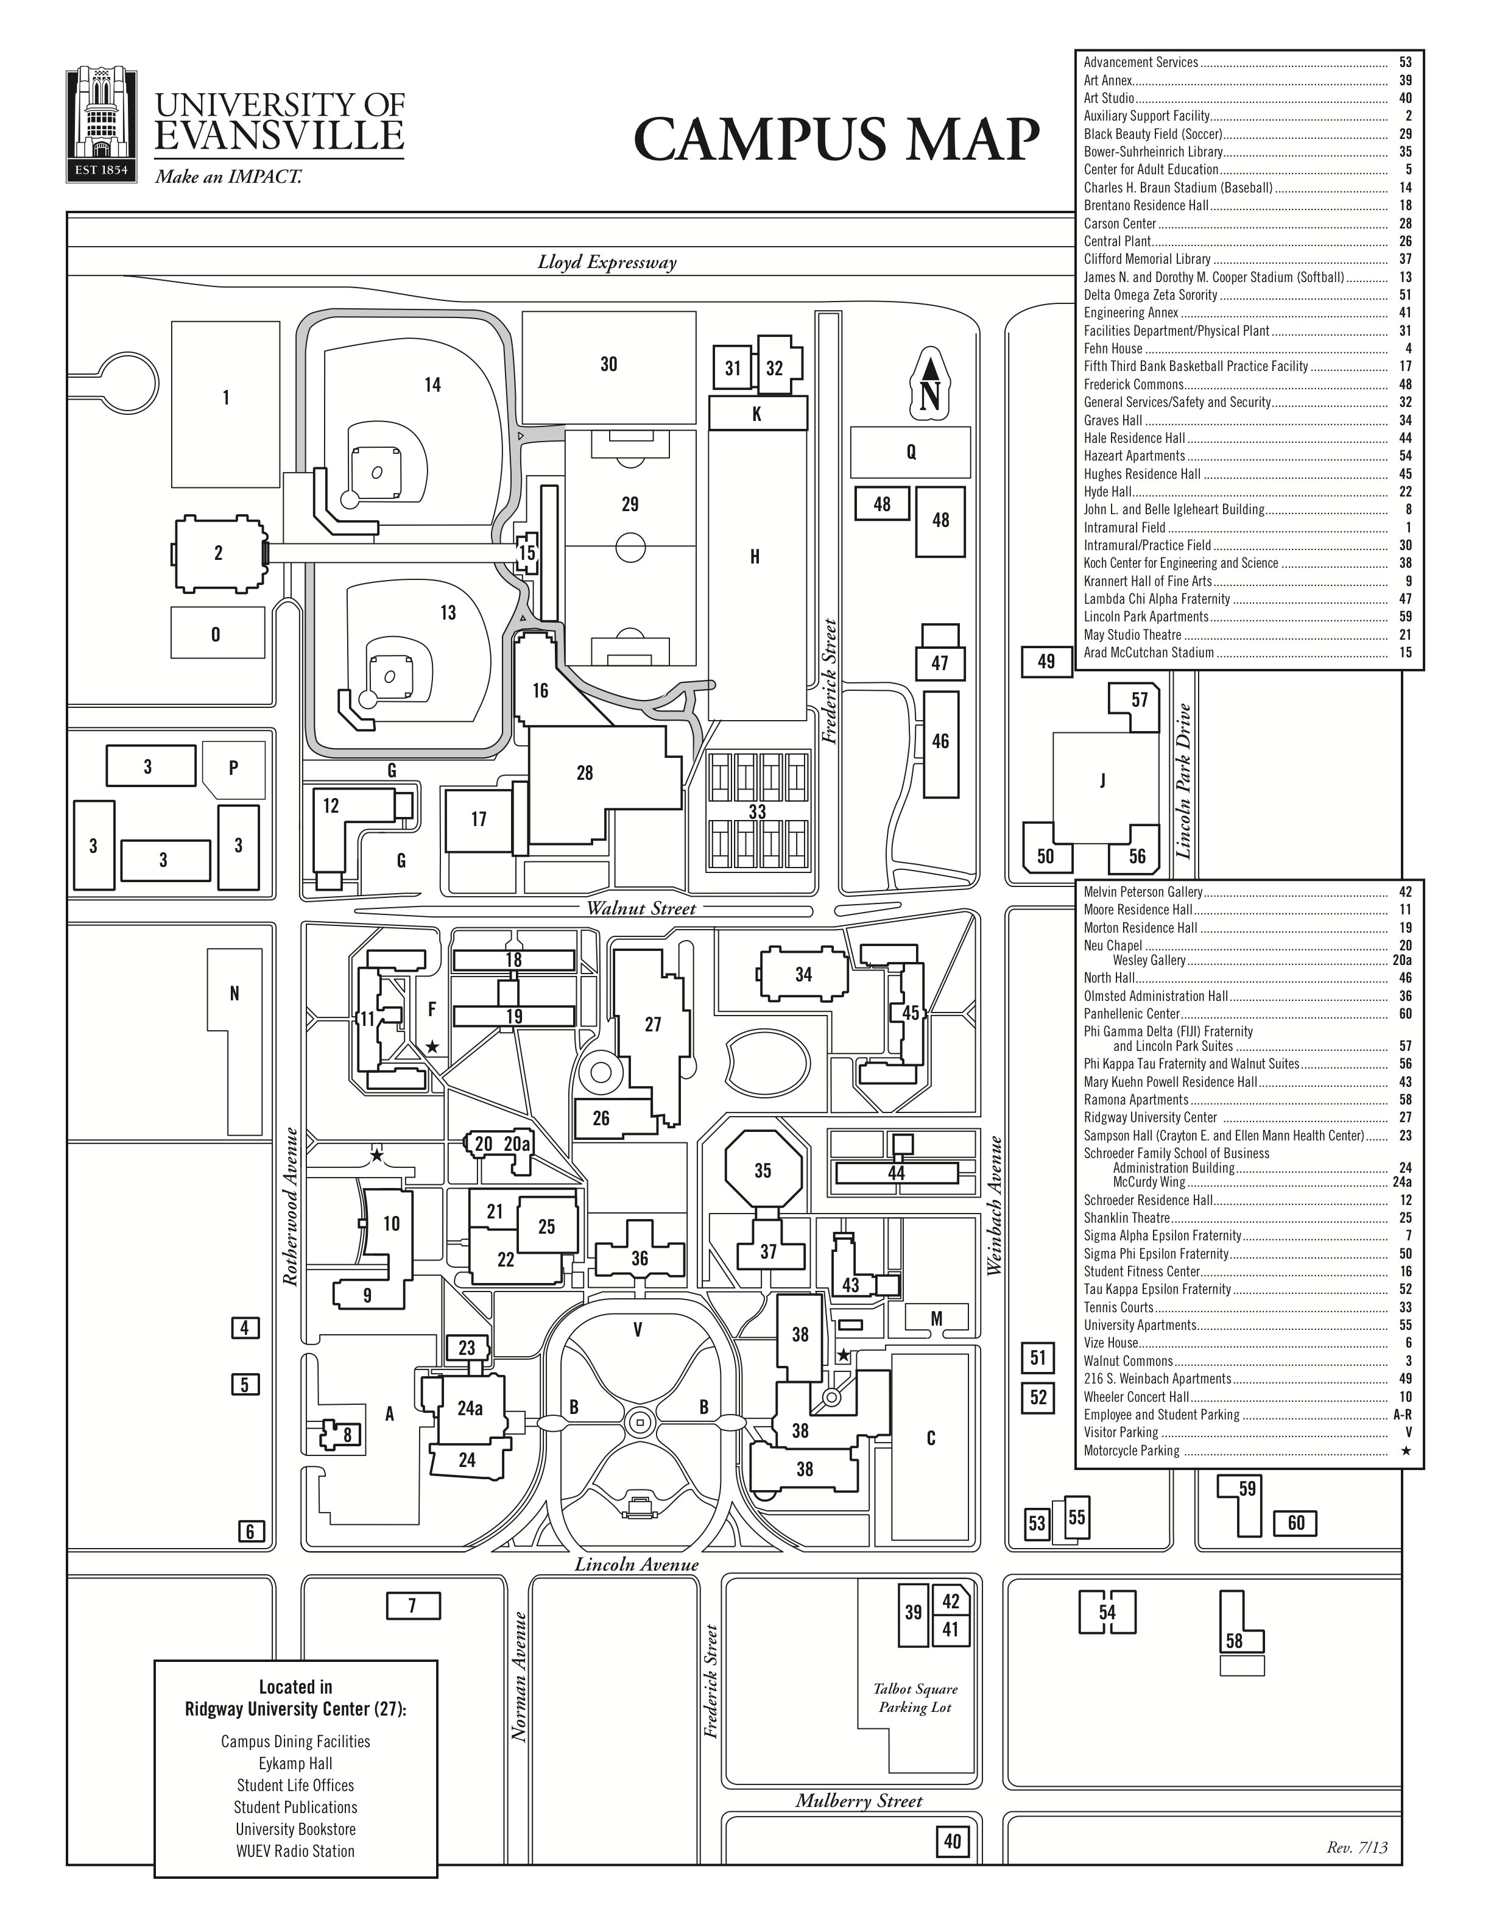

If you look at the map, there is a small building between building number 19 (your residence hall) and number 18 (Brentano Residence Hall). This is the area where I will have some tables and chairs set up for your breakfast and lunch.

Tuesday morning you will deliver your Bottle Caps to Green Tree Plastics at 7:00AM!!
Mr. Mike Keown has volunteered his time to drive his own truck and the trailer of Dr Gale Neal filled with 2600 pounds of bottle caps to “Green Tree Plastics” for us. He is our hero!!
https://www.facebook.com/Green-Tree-Plastics-ABC-Partnership-197651666987209/
ABC (A Bench for Caps) PROMISE PARTNERSHIP ORIGIN ABC was designed for school children by a team of 6 eighth graders in March 2010, as their entry in a nation-wide academic competition in community problem solving. Topic: recycling.

https://www.greentreeplastics.com/

https://www.greentreeplastics.com/abc-program/
The ABC program is the one in which we have been participating.
- Website: greentreeplastics.com
- Phone: (866) 397-5742

University of Evansville, Evansville, IN to Green Tree Plastics 1107 E Virginia St, Evansville, IN
- Head toward S Frederick St on E Walnut St 0.1 mi/
- Turn left onto S Weinbach Ave 0.3 mi/
- Turn left onto E Division St 0.4 mi/
- Take left ramp onto E Lloyd Expy (IN-66) 0.2 mi/
- Take ramp onto US-41 N toward IN-62 E/IN-66 W/Vincennes 0.4 mi/
- Turn left onto E Virginia St 0.2 mi/
- Arrive at E Virginia St. Your destination is on the left
After the benches are loaded you will head back to Evansville University for breakfast and to clean up your room and to pack. You will meet back at a location identified by Ms Hamilton for your campus tour.
Your on-campus schedule for Tuesday, July 9 is as follows:
9:00 am – Campus Tour – Departs from Morton Residence Hall
10:00 am – Admission Session with Admission Team and STEM presentation
11:00 am – Return to Morton Residence Hall for lunch and to gather your luggage, sleeping bags and other items. Leave your room as if you had never been there.
12:00 pm – Depart campus

You will load the bus by 12:15 and head to Mammoth Cave Kentucky.
There are 95.46 mi between University of Evansville, Indiana and Mammoth Cave, Kentucky and there are 147 mi (236.57 kilometers) by road.
It would take 2 hours 28 mins to go from University of Evansville, Indiana to Mammoth Cave, Kentucky.
University of Evansville, Indiana and Mammoth Cave, Kentucky are in the same time zone (CDT).

https://www.nps.gov/maca/index.htm

You will be staying in the woodland cottages. Not far from the Visitors Center on this map.
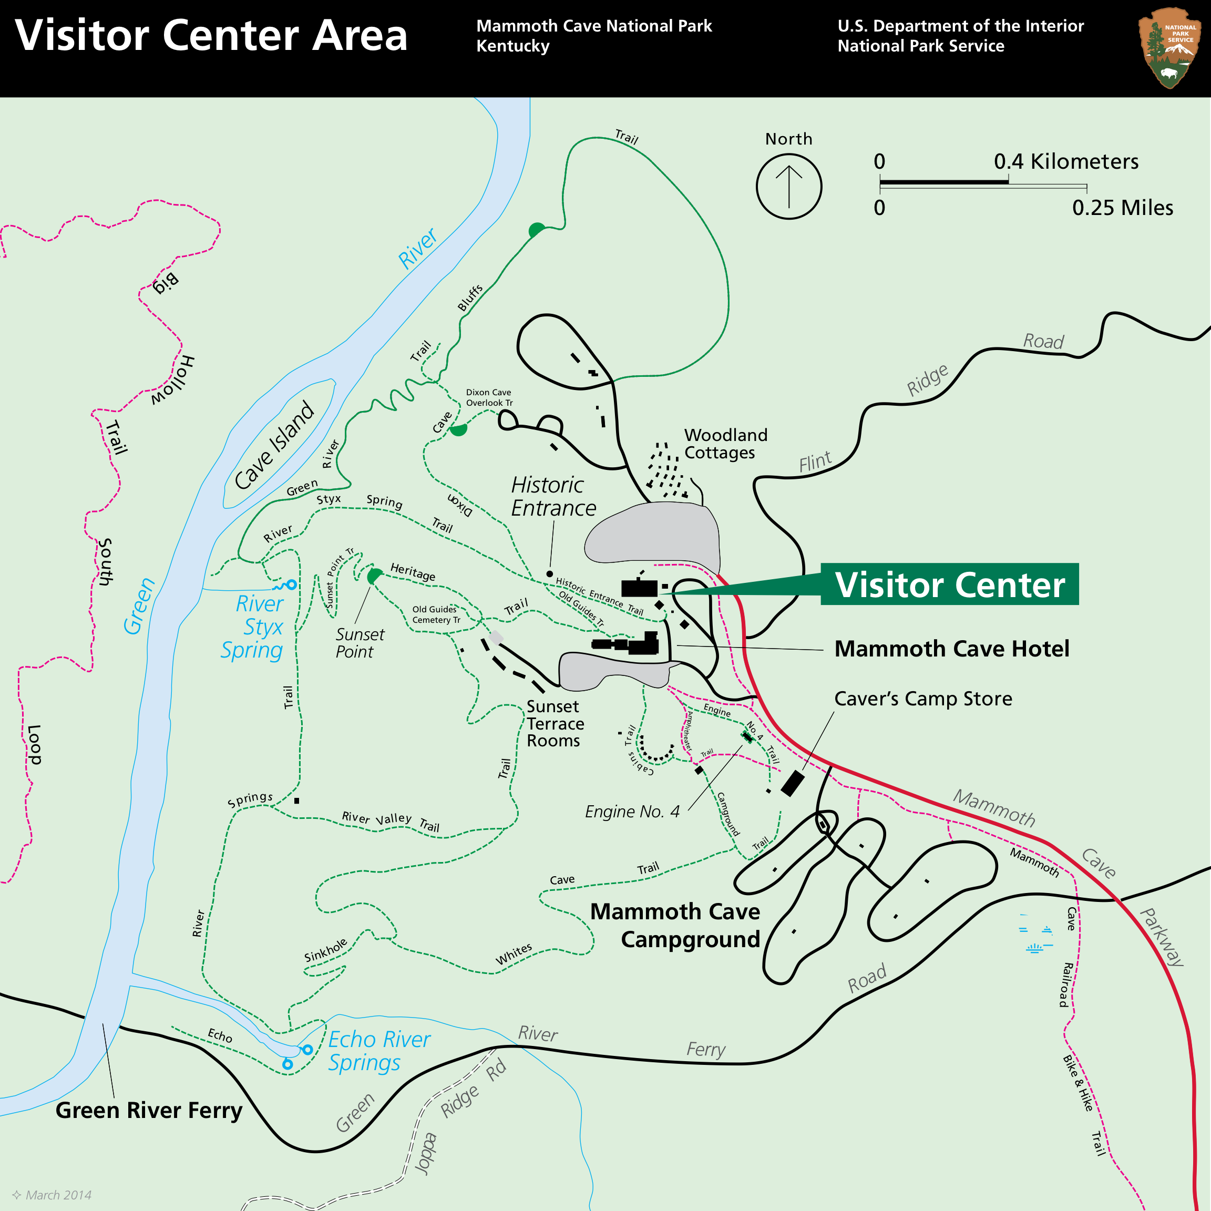

https://mammothcavelodge.com/lodging/ - woodland_cottage
Check out where you will spend the night. There are bed linens and bath towels etc. You may use the sheets and make the bed or use your sleeping bag, your choice. The females are in the cottage with four bedrooms each with two queen sized beds and a roll away bed. The Males are in the three bedrooms cottage, each with two queen sized beds and one roll away bed in each bedroom. There is no air conditioning. There is a ceiling fan. It is expected to be hot and humid.

You should arrive about 3:00 to check in.
Ms Hamilton, Ms Lanatta and Mr. Chapman will decide about your activities from 3:00- 7:00. You may enjoy dinner by a campfire. Ms Hamilton will purchase firewood at the Park. You can roast hotdogs and for dessert create Somore’s using graham crackers, marshmallows and chocolate.
By 7:00 head to the amphitheatre for a talk by the Forest Ranger. The program begins at 7:30.
You will head to your cottages by 9:00. It has been a long day!!

Check out this cave video
https://video.search.yahoo.com/yhs/search?fr=yhs-sz-001&hsimp=yhs-001&hspart=sz&p=Mammoth+Cave - id=1&vid=6154797fe9e5620f6d8455a709cde03c&action=click

Wednesday morning – wake up refreshed and ready for another adventure. After breakfast Ms Jennifer Shackelford a National Park Ranger will meet you at an enclosed shelter in the park.
Start at the Visitor Center parking lot.
As you follow the road around the parking area you will see and pass yellow cottages on your right. On the far side of these cottages you will see a sign indicating the entrance to the park’s picnic area and the Environmental Education Office.
Turn RIGHT into the picnic area.
The first building on your LEFT in the picnic area is the Enclosed Shelter. Parking is available in front of and/or near the shelter.
Ms Shackelford will lead you on a cave tour and involve you in a national research project about mercury levels in dragonfly larvae. This is a Citizens Science Project being done by several National Parks. This will be a published report. Your research will be complied with others and published. You are truly scientists!

Wednesday, July 10th - After lunch you will load on the bus and head to Chattanooga, Tennessee.
At 7:00 PM – Campers arrive in Chattanooga, Tennessee at the Creative Discovery Museum.
Directions & Parking
Located at the corner of Chestnut and 4th Streets in Chattanooga, Creative Discovery Museum is easily accessible from I-24.
321 Chestnut St 423 756-2738 https://www.cdmfun.org/page/directions to Creative Discovery Museum https://www.cdmfun.org/parking
Take your sleeping bag, luggage and other personal items to the museum. No need to take food this time. The museum will provide supper and breakfast.

Creative Discovery Museum Lock-Ins are tons of fun and will provide a memorable experience for your group that will be hard to forget! Lock-In and Museum After Dark Experience participants will eat dinner at the Museum, shop in the Gift Shop, play games, participate in a workshop of their choice, sleep in the Museum, and wake up to a great breakfast! · S’mores and Stars: Students will identify constellations, listen to Greek myths about the stars, make s ‘mores, and view the night sky from the Museum rooftop.

As you wake the morning of July 11th you will pack up, eat breakfast and head to the bus for the trip to Thomasville. On the way your counselors will select a place for you to eat lunch. This will be the last stop before you get to Thomasville. You should arrive back on TU campus between 3:00-4:00. Weary but filled with so much that you have learned about our world! You will have traveled to five states in four days!

You can be change makers for good- you are change makers for good!
July 12th
Friday morning you can complete your documentaries, travel to the Thomasville City Schools warehouse and the Thomas County Schools warehouse to see your benches and speak to those receiving the benches. We wish you could be at the schools witnessing the students enjoying their new benches. Seek out the bench at your school when you return this fall. You have made a difference- 2600 pounds of bottle caps NOT in a landfill and nice Buddy Benches for each public school in our area.

2:30- Smith Bonvillian Hall Presentation of documentaries and a reception. I can hardly wait !!!

